Plurals and Pronunciation

Many words in English form their plural form by adding an “s” on the end of the word.

Singular (1) | Plural (2+)
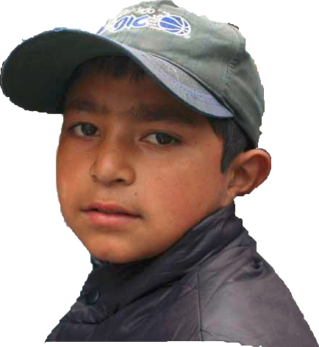  Boy | 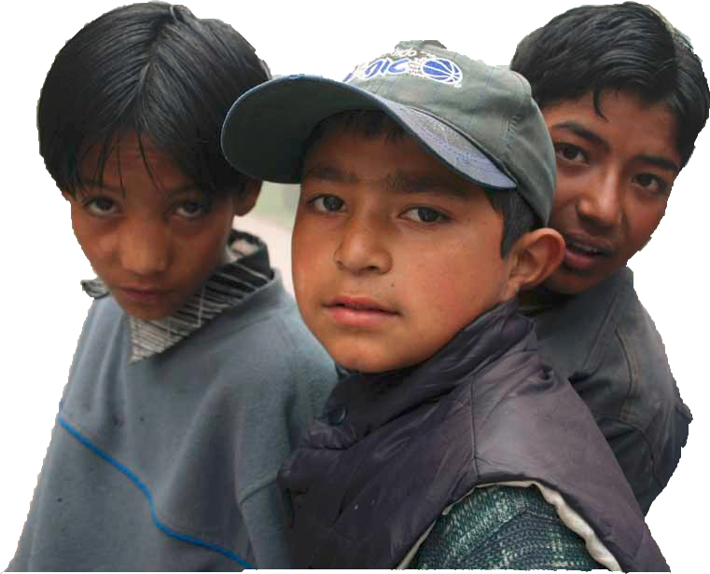  Boys
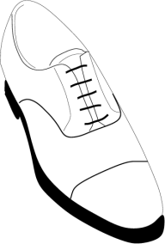  Shoe | 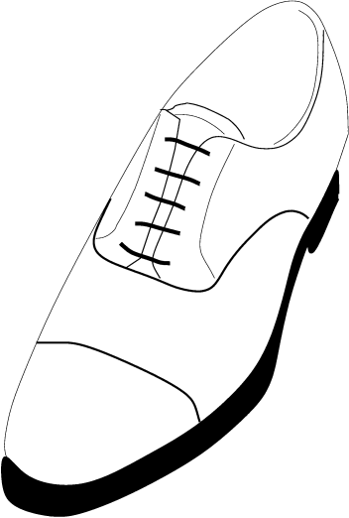  Shoes

Sometimes the “s” is pronounced with a hissing, “snake” sound:
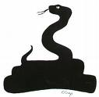 Sssssssss

The word “Cats” is pronounced “Cats(ssss)”

Other times, the “s” is pronounced with a buzzing, “bee” sound:
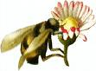Zzzzzzzzz
P00011

The word “Dogs” is pronounced “Dogz(zzzz).”

Peter Schmitt / Open-ESL.org PJS – 02/04/2010
”Regular” plurals- just add “s”
Singular (1) | Plural (2+)
Room | Rooms | (Zzzz)
Rat | Rats | (Ssss)
Apple | Apples | (Zzzz)
Pen | Pens | (Zzzz)
Pencil | Pencils | (Zzzz)
Radio | Radios | (Zzzz)
Map | Maps | (Ssss)
Cat | Cats | (Ssss)
Dog | Dogs | (Zzzz)
Elephant | Elephants | (Ssss)
Goat | Goats | (Ssss)
Hat | Hats | (Ssss)
Jar | Jars | (Zzzz)
King | Kings | (Zzzz)
Lion | Lions | (Zzzz)
Nest | Nests | (Ssss)
Pig | Pigs | (Zzzz)
Queen | Queens | (Zzzz)
Rainbow | Rainbows | (Zzzz)
Tree | Trees | (Zzzz)
Umbrella | Umbrellas | (Zzzz)
Violin | Violins | (Zzzz)
Zebra | Zebras | (Zzzz)

Some words that end in “y” make a plural by replacing the “y” with “ies”:
Singular (1) | Plural (2+)
Baby | Babies | (Zzzz)
Party | Parties | (Zzzz)
Patty | Patties | (Zzzz)
Fly | Flies | (Zzzz)
Country | Countries | (Zzzz)
City | Cities | (Zzzz)

Other words have plural forms that are very different than the singular:
Singular (1) | Plural (2+)
Man | Men
Goose | Geese
Woman | Women
Child  Mouse | Children  Mice
Cactus | Cacti
There are a few words where the singular and plural are the same:
Singular (1) | Plural (2+)
Sheep  Aircraft  Fish | Sheep  Aircraft  Fish (or fishes)
P00011

