“Family Tree”
Section | Pages
Family Tree Image & Jim’s Family | 2
Tom’s Family | 3
Answer Blank for Questions | 4
Text of questions (Jones’s version) | 5
Text of questions (Jones’ version) | 6

Content created by Peter Schmitt
Audio by Rhonda Schmitt

This work is made available through Creative Commons Attribution-ShareAlike 4.0 International License – Peter Schmitt Open-ESL.org
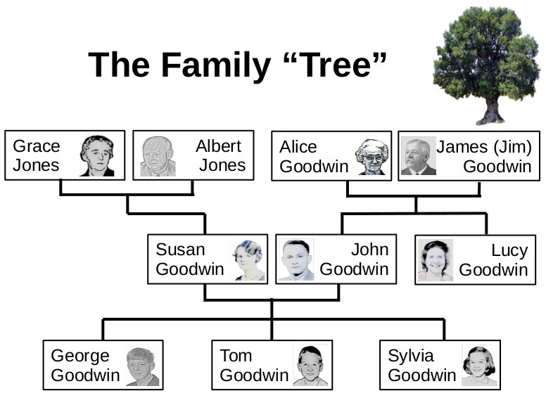
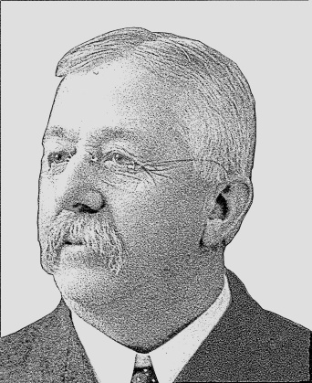
Jim’s Family
This is Jim.
His full name is James Goodwin.
But everyone calls him Jim.
Jim is married. His wife’s name is Alice
They have two children.
Their son is named John. Their daughter is named Lucy.
Their son John has three children. John’s children are Jim’s grandchildren.
P00194
Jim has a grandson named George. Jim’s other grandson is named Tom.
His granddaughter is named Sylvia.
Peter Schmitt / Open-ESL.org
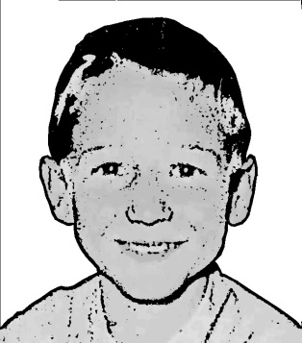
Tom’s Family
This is Tom.
His full name is Thomas Goodwin.
But everyone calls him Tom.
Tom has a sister and a brother.

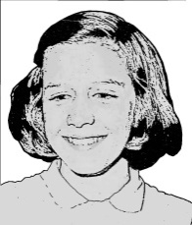
His sister’s name is Sylvia.
His brother’s name is George.
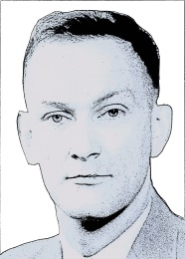
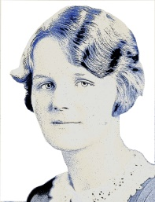
Susan is Tom’s mother.
John is Tom’s father.
They are Tom’s parents.

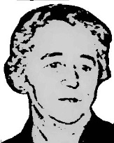
Tom has four grandparents.
His mother’s parents are Grace and Albert.
Tom calls them Grandma Jones and Grandpa Jones.
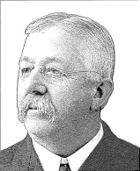
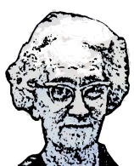
His father’s parents are Alice and James.
Tom calls her Grandma Goodwin.
Everyone calls Tom’s grandfather “Jim”.
So Tom calls him “Grandpa Jim”.
More words
In English we have formal and informal words for parents and grandparents.
Formal | Informal  P00194
Mother | Mom
Father | Dad
Grandmother | Grandma
Grandfather | Grandpa
Peter Schmitt / Open-ESL.org
Questions
(Each question is repeated three times)
- A B C
- A B C
- A B C
- A B C
- A B C

Peter Schmitt / Open-ESL.org
Questions
- Who is Alice Goodwin’s son?
A) Susan Goodwin
B) Tom Goodwin
C) John Goodwin
- Who is Albert Jones’s granddaughter?
A) Grace Jones
B) Susan Goodwin
C) Sylvia Goodwin
- Who is Tom Goodwin’s grandfather?
A) George Goodwin
B) John Goodwin
C) Albert Jones
- Who is George Goodwin’s sister?
A) Tom Goodwin
B) Sylvia Goodwin
C) Grace Jones
- Who is Grace Jones’s granddaughter?
A) Sylvia Goodwin
B) Susan Goodwin
C) George Goodwin
Peter Schmitt / Open-ESL.org

P00194
Questions
- Who is Alice Goodwin’s son?
A) Susan Goodwin
B) Tom Goodwin
C) John Goodwin
- Who is Albert Jones’ granddaughter?
A) Grace Jones
B) Susan Goodwin
C) Sylvia Goodwin
- Who is Tom Goodwin’s grandfather?
A) George Goodwin
B) John Goodwin
C) Albert Jones
- Who is George Goodwin’s sister?
A) Tom Goodwin
B) Sylvia Goodwin
C) Grace Jones
- Who is Grace Jones’ granddaughter?
A) Sylvia Goodwin
B) Susan Goodwin
C) George Goodwin
Peter Schmitt / Open-ESL.org

P00194

As a listening exercise, the text of the questions would not be given to the student. Instead they would rely on listening comprehension.
Given the controversy and lack of agreement regarding the construction of plurals for singular nouns ending in “s” versions for both options have been included.

