Paul Bunyan - Childhood A00166
Section | Pages
Story with words filled in | 2
Vocabulary picture sheet | 3
Student “Fill in” document | 4

This material was adapted by Peter Schmitt from a variety of different versions of Paul Bunyan folktales.
Audio is read by Michael Wright and Bruce Stout.

Paul Bunyan - Childhood
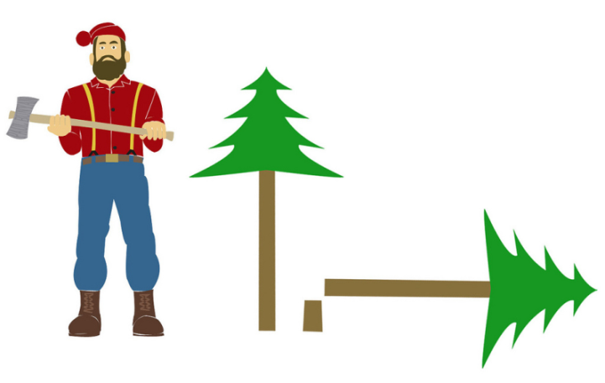
Paul Bunyan is the fictional subject of some American folk ___stories_. He was a giant ___who_ worked as a lumberjack. A lumberjack is a person who cuts down trees to be made into lumber. Lumber is the word for the wood used to __make__ houses, furniture, etc. In the past, lumberjacks ___cut trees with axes, but now lumberjacks ___use chainsaws.
The legends of Paul Bunyan begin with ___stories__ of his childhood.

Paul Bunyan’s Childhood
Paul Bunyan was from the __state__ of Maine in the United States. When he was born he was so __big__ that it took five storks to carry him. He grew quickly. After just a week, he had to __wear__ his father’s clothes. Instead of a baby carriage, he was taken for rides in a huge wagon pulled by oxen. He became __so__ big, that he could not fit in his cradle. So his parents __put__ him on a big raft in the ocean. __When__ Paul turned over in his sleep it caused huge waves in the ocean. The waves __were__ so big that they sunk ships that were nearby.
On Paul Bunyan’s ___first__ birthday, his father gave him a pet blue ox named “Babe.” As a child Paul ___played__ with an ax and a saw instead of toys like the other children. He would eat 40 bowls of oatmeal and still be ___hungry__.
Paul Bunyan became bigger and bigger. When he was a young ___boy_ he was already so big that his ___shirts_ had to use wagon wheels as buttons.

Tall Tales
P00166
We call this ___type__ of story a “Tall Tale.” This means that the story is so exaggerated that it cannot be ___true___, and everybody knows it cannot be true.
Vocabulary
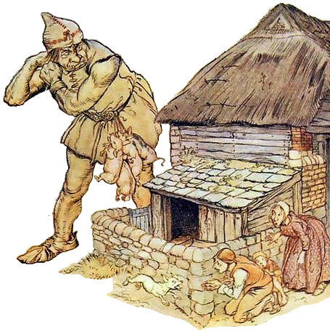  Giant | 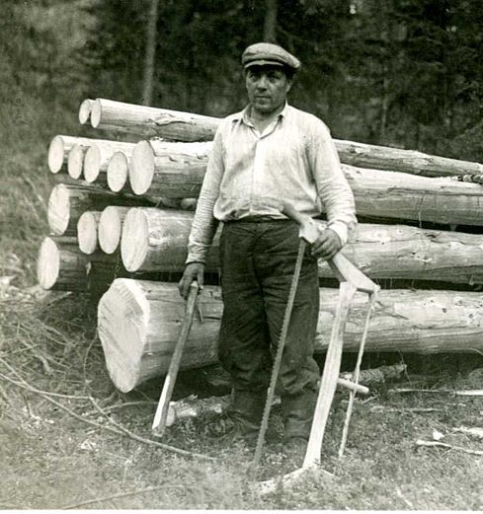Lumberjack | 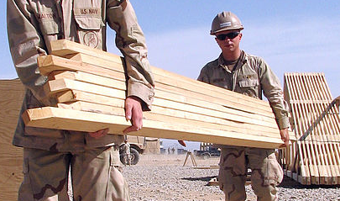Lumber
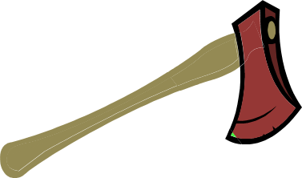  Ax (or Axe)  Plural: Axes | 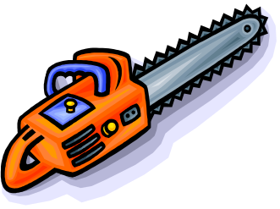Chainsaw | 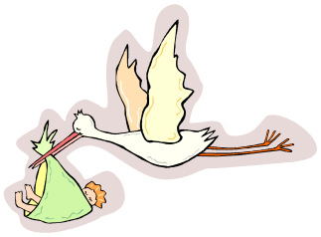  Stork
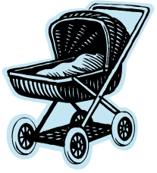  Baby carriage | Wagon | 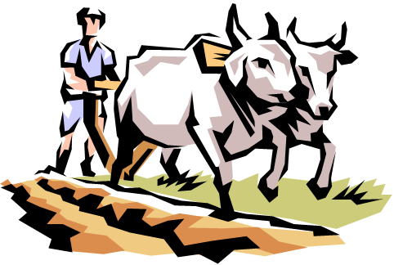  Ox (Plural: Oxen)
  Cradle | 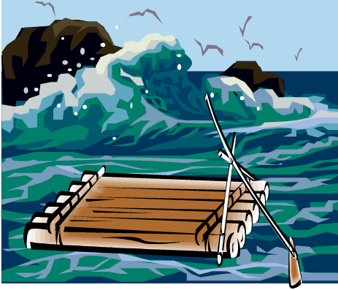  Raft |   Waves
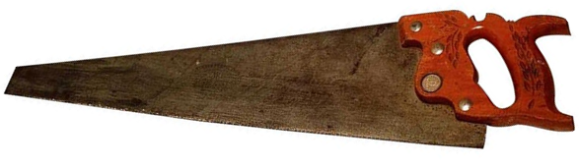  A Saw (noun) | 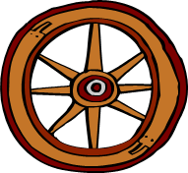  Wagon Wheel | 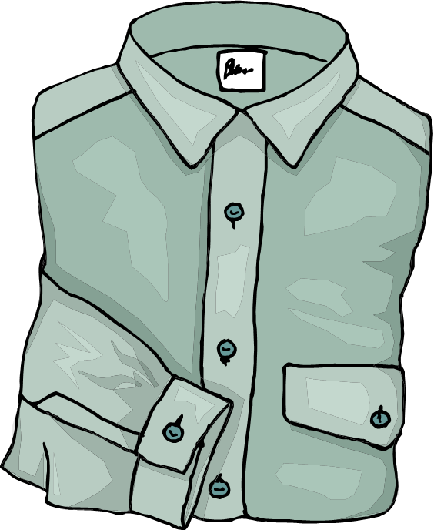  Button  Plural: Buttons
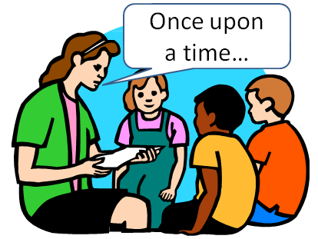  Tale (Story) | 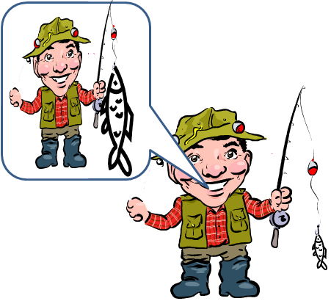  To Exaggerate | 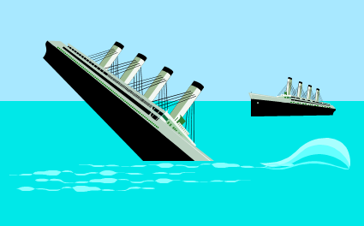  To Sink  (past: Sunk)

Paul Bunyan - Childhood
Paul Bunyan is the fictional subject of some American folk __________. He was a giant _________ worked as a lumberjack. A lumberjack is a person who cuts down trees to be made into lumber. Lumber is the word for the wood used to ___________ houses, furniture, etc. In the past, lumberjacks _______ trees with axes, but now lumberjacks ________ chainsaws.
The legends of Paul Bunyan begin with _____________ of his childhood.

Paul Bunyan’s Childhood
Paul Bunyan was from the __________ of Maine in the United States. When he was born he was so ___________ that it took five storks to carry him. He grew quickly. After just a week, he had to __________ his father’s clothes. Instead of a baby carriage, he was taken for rides in a huge wagon pulled by oxen. He became _______ big, that he could not fit in his cradle. So his parents _______ him on a big raft in the ocean. _____________ Paul turned over in his sleep it caused huge waves in the ocean. The waves _________ so big that they sunk ships that were nearby.
On Paul Bunyan’s _____________ birthday, his father gave him a pet blue ox named “Babe.” As a child Paul __________ with an axe and a saw instead of toys like the other children. He would eat 40 bowls of oatmeal and still be _________________.
Paul Bunyan became bigger and bigger. When he was a young ________ he was already so big that his ___________ had to use wagon wheels as buttons.

Tall Tales
P00166
We call this ___________ of story a “Tall Tale.” This means that the story is so exaggerated that it cannot be ____________, and everybody knows it cannot be true.

