March Comes In Like A Lion – P00189
Section | Pages
Audio transcript | 2
Student “Fill in” document | 3

This material was created by Peter Schmitt in March 2014.
Audio by Rhonda Schmitt
This work is made available through Creative Commons Attribution-ShareAlike 4.0 International License – Peter Schmitt Open-ESL.org

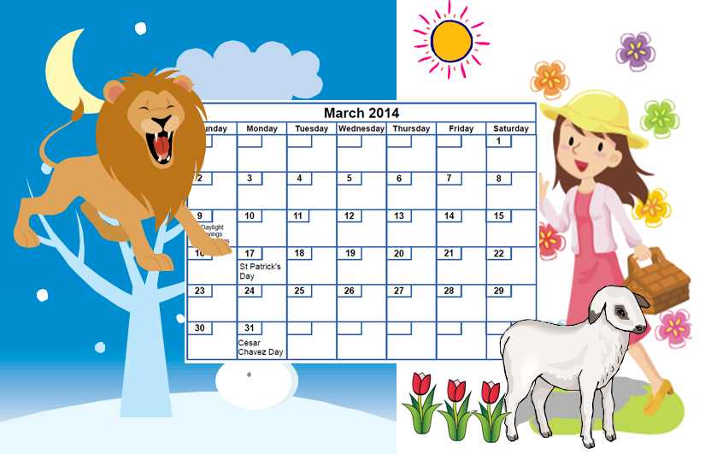
March
I’m tired of winter. I want to see flowers.
I want to hear birds.
They say:
“March comes in like a lion and goes out like a lamb.”
I like March. I’m ready for spring!

P00189

Peter Schmitt / Open-ESL.org
March
____ tired of winter. I ______ to see ___________.
____ want to ______ _________.
They say:
“March _____ in ____ a lion ______ goes _____ like a lamb.”
I ______ March. ____ ready for _________!
P00189

Peter Schmitt / Open-ESL.org

