April Showers – P00196
Section | Pages
Audio transcript | 2
Student “Fill in” document | 3

Content created April/2014 by Peter Schmitt, Audio by Rhonda Schmitt
This work is made available through Creative Commons Attribution-ShareAlike 4.0 International License – Peter Schmitt Open-ESL.org
April Showers
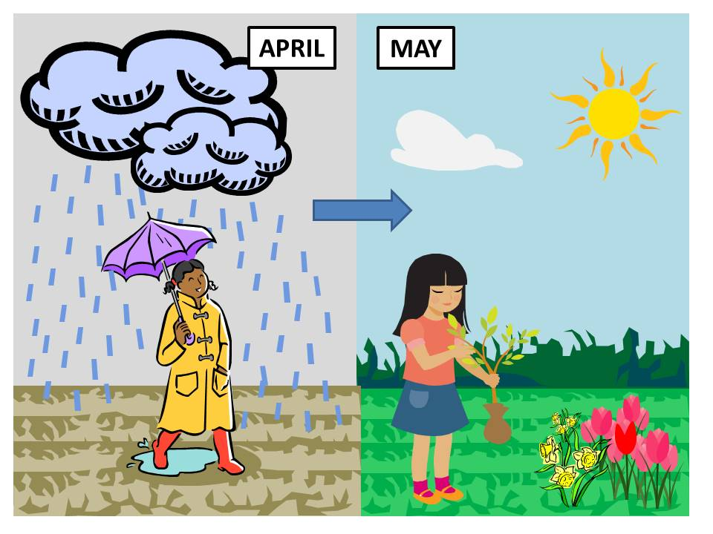

April is a good month. Spring is here!
It often rains in April.
When there is a little bit of rain, we call it a shower.
They say “April showers bring May flowers”.
P00196
I love flowers! I am ready for May!
Peter Schmitt / Open-ESL.org
April Showers

April ___ a good ______. ________ is here!
It often ______ in April.
When ______ is a little bit of rain, ___ call it a shower.
They say “April showers bring May flowers”.
P00196
I ______ flowers! I ____ ready for _______!

Peter Schmitt / Open-ESL.org

