“American History: The 1960s – A decade of Change”
Section | Pages
Full Document | 2 - 3
Student “Fill in” document | 4 - 5

This material was adapted from material on the “Voice of America” web site which is not covered by copyrights.
(http://learningenglish.voanews.com/content/american-history-the-1960s-10-years-that-changed-a-nation-134041543/114624.html)


American History: The 1960s – A decade of Change
(condensed from VOA-Special English)
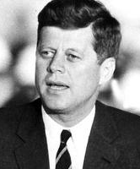
The nineteen sixties began with the election of the first president born in the twentieth century -- John Kennedy. For many Americans, the young president represented a spirit of hope for the nation. When Kennedy was murdered in nineteen sixty-three, many felt that their hopes died, too. This was especially true of young people, and members and supporters of minority groups.
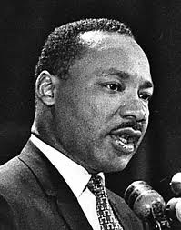
A time of innocence and hope soon began to look like a time of anger and violence. More Americans protested to demand an end to the unfair treatment of black citizens. Many more protested to demand an end to the war in Vietnam. And many protested to demand full equality for women
By the middle nineteen fifties, many young Americans’ parents had jobs that paid well. They taught their children middle class values. Later, many young Americans began to question these beliefs. They rebelled. Their dissatisfaction was strongly expressed in music.
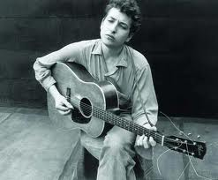
Rock and roll music had become very popular in America. The musicians thought the words were extremely important. As singer and song writer Bob Dylan said, "There would be no music without the words." Bob Dylan produced many songs of social protest. One was called “Blowin’in the Wind.”
(MUSIC)
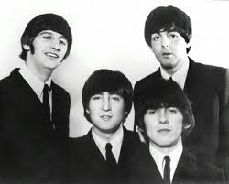
In addition to songs of social protest, rock and roll music continued to be popular in America during the nineteen sixties. The most popular group, however, was not American. It was British -- the Beatles -- four rock and roll musicians from Liverpool.
A00102
(MUSIC)
The Beatles' song "I Want to Hold Your Hand" went on sale in the United States at the end of nineteen sixty-three. Within five weeks, it was the biggest-selling record in the country.
(MUSIC)
Other songs, including some by the Beatles, sounded more revolutionary.
Many Americans took no part in the social revolution. Instead, they continued leading normal lives of work, family, and home. Others, the activists of American society, were busy fighting for peace, and racial and social justice.
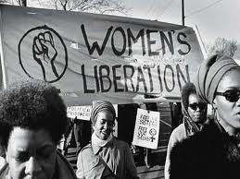
(MUSIC: “I Am Woman”/Helen Reddy)
Women's groups, for example, were seeking equality with men. They wanted the same chances as men to get a good education and a good job. They also demanded equal pay for equal work.
In the early 1960s a committee was appointed to investigate the condition of women. The committee’s findings helped lead to new rules and laws. The nineteen sixty-four Civil Rights Act guaranteed equal treatment for all groups. This included women.
The movement for women's equality was known as the women's liberation movement. They acted together to win recognition for the work done by all women in America.
Check your understanding-
True or False?

1. | John Kennedy was elected President in 1960. | T F
2. | The 1960s was a decade of social change in the United States. | T F
3. | The most popular rock and roll band in the 1960s was from New York. | T F
4. | Bob Dylan said that the words to songs were not important. | T F
5. | The struggle for women’s equal rights was known as the women’s liberation movement. | T F
American History: The 1960s – A decade of Change
(condensed from VOA-Special English)
The nineteen sixties _______ with the election of the first president born in the twentieth century -- John Kennedy. For _____ Americans, the ______ president represented a spirit of hope for the nation. When Kennedy was murdered in ________ sixty-three, many felt _______ their hopes died, too. This was especially true of young __________, and members and supporters of minority groups.
A _______ of innocence and hope soon began to _____ like a time of anger and violence. More Americans protested to demand an ____ to the unfair treatment of black citizens. Many ____ protested to demand an end to the ___ in Vietnam. And many protested to demand full equality for women
By the middle nineteen fifties, many ______ Americans’ parents had jobs that paid well. They ______ their children middle class values. Later, many young Americans began to question these beliefs. _____ rebelled. Their dissatisfaction was strongly expressed in ______.
Rock and roll music had become ______ popular in America. The musicians thought the words _____ extremely important. As singer and song writer Bob Dylan ____, "There would be no music without the ________." Bob Dylan produced many songs of social protest. One was called “Blowin’in the Wind.”
(MUSIC)
In addition to songs of _________ protest, rock and roll music continued to be popular in America during the nineteen sixties. The ________ popular group, however, was ___ American. It was British -- the Beatles -- four rock and roll musicians from Liverpool.
A00102
(MUSIC)
The Beatles' song "I Want to Hold Your Hand" went on sale in the United States at the ____ of nineteen sixty-three. Within five weeks, it was the biggest-selling record in the ___________.
(MUSIC)
Other songs, including some by the Beatles, sounded more revolutionary.
Many ________s took no part in the social revolution. Instead, they continued leading normal ______ of work, family, and home. Others, the activists of American society, ______ busy fighting for peace, and racial and social justice.
(MUSIC: “I Am Woman”/Helen Reddy)
Women's groups, for _______, were seeking equality with men. They wanted the _____ chances as men to get a good __________ and a good job. They also demanded equal ______ for equal work.
In the _____ 1960s a committee was appointed to investigate the condition of women. The committee’s findings helped lead to _______ rules and laws. The nineteen sixty-four Civil Rights Act guaranteed equal treatment for ____ groups. This included women.
The movement for women's equality ______ known as the women's liberation movement. They acted __________ to win recognition for the work done by all women in America.
Check your understanding-
True or False?

1. | John Kennedy was elected President in 1960. | T F
2. | The 1960s was a decade of social change in the United States. | T F
3. | The most popular rock and roll band in the 1960s was from New York. | T F
4. | Bob Dylan said that the words to songs were not important. | T F
5. | The struggle for women’s equal rights was known as the women’s liberation movement. | T F

