“The American Diner”
Section | Pages
Full Document | 2 - 3
Student “Fill in” document | 4 - 5

This material was adapted from material on the “Voice of America” web site which is not covered by copyrights.
(http://learningenglish.voanews.com/content/a-few-steps-up-from-fast-food-and-down-the-road-from-fine-dining-lies-the-diner-131421398/112615.html)
The image is also from “Voice of America”.


The American Diner 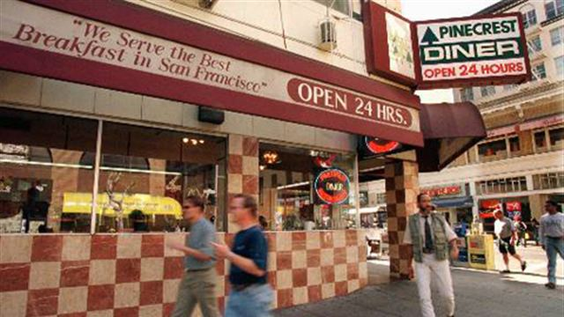
A diner is a small restaurant. Old-time diners were built in a factory and transported to their place of business.
Diners usually have an open kitchen and a long counter. People can sit at the counter and watch the cooks make their food.
A diner can be a place for people in a community to gather, drink coffee and talk. Or it can be a welcome stop for travelers on the road.
Diners are known for “comfort food.” This kind of food reminds people of the meals their mothers and grandmothers made. Meatloaf is a good diner meal. It is baked in an oven and traditionally served with potatoes that are mashed and mixed with milk or cream.
Most diners serve breakfast meals all day long, not just in the morning. Pancakes are a favorite breakfast food at diners. They are a thin, round cake made of flour, eggs and milk -- all cooked on a greased surface.
Another popular diner food is a milkshake. This sweet, thick drink is made of ice cream and milk. In the nineteen forties and 'fifties, teenagers would meet at diners to talk, drink milkshakes and listen to music.
A00092
Many diners had jukeboxes that people could operate from their tables. Someone could put in a coin, choose a song and then listen as it played throughout the restaurant.
Diners are much less common than they used to be. But they still hold a place in the American imagination. Several large companies have opened new diners that recreate the look of the past.
Some people, though, are loyal to the old diners that have stayed in business. These people prefer to eat at places that have remained in the same spot for years. They eat at diners so often that the waitresses remember their names and ask about their families.
Test your comprehension!
True or False:
- Diners are large restaurants. | T F
- The kitchen in a diner is in a back room. | T F
- People from the community gather, drink coffee and talk in diners. | T F
- Diners are a place to try new, strange foods. | T F
- Diners do not serve breakfast. | T F
- Pancakes are made from flour, milk, and eggs. | T F
- People at diners listened to music on a “jukebox.” | T F
- Today diners are very common and are found almost everywhere. | T F
- Loyal customers like to try new places every week when they eat at a restaurant. | T F
- Diners are friendly places where waitresses often ask about the family of a customer. | T F
A00092
The American Diner
A diner is a small ______________. Old-time diners ________ built in a factory and transported to their place of business.
Diners usually have an open ________ and a long counter. People can sit at the counter and watch the cooks make their food.
A diner can be a place for __________ in a community to gather, drink ________ and talk. Or it can be a welcome stop for travelers on the road.
Diners are known for “comfort food.” This kind of food reminds __________ of the meals their __________ and grandmothers made. Meatloaf is a good diner meal. It is baked in an ________ and traditionally served with potatoes that are mashed and mixed with milk or cream.
Most diners serve ____________ meals all day long, not just in the morning. Pancakes are a favorite ___________ __________ at diners. They are a thin, round cake made of flour, ________ and milk -- all ______________ on a greased surface.
Another popular diner food is a milkshake. This sweet, thick drink is _______ of ice cream and milk. In the nineteen forties and 'fifties, teenagers would meet at diners to talk, drink milkshakes and listen to music.
A00092
Many diners had jukeboxes that people could operate from their __________. Someone could put in a coin, choose a _______ and then listen as it played throughout the ________________.
Diners are much _______ common than they used to be. But they still hold a place in the American imagination. Several ________ companies have opened new diners that recreate the ______ of the past.
Some people, though, are loyal to the _______ diners that have stayed in business. These people prefer to eat at places that have remained in the same spot for years. They eat at diners so often that the waitresses ______________ their names and _______ about their families.
Test your comprehension!
True or False:
- Diners are large restaurants. | T F
- The kitchen in a diner is in a back room. | T F
- People from the community gather, drink coffee and talk in diners. | T F
- Diners are a place to try new, strange foods. | T F
- Diners do not serve breakfast. | T F
- Pancakes are made from flour, milk, and eggs. | T F
- People at diners listened to music on a “jukebox.” | T F
- Today diners are very common and are found almost everywhere. | T F
- Loyal customers like to try new places every week when they eat at a restaurant. | T F
- Diners are friendly places where waitresses often ask about the family of a customer. | T F
A00092

