Benjamin Franklin – Part One A00115
Section | Page(s)
“Fill in” document with answers | 2 - 3
Student “Fill in” document | 4 - 5

This material was adapted by Peter Schmitt from the book “Four Great Americans: Washington, Franklin, Webster, and Lincoln. A book for young Americans.” by James Baldwin. The book is now in the public domain.
The full text of the book is available through the Gutenberg Project.
A public domain audio recording is available through Librivox.com
Audio is read by Sibella Denton.
(http://www.gutenberg.org/ebooks/11174
http://librivox.org/four-great-americans-by-james-baldwin/)



THE STORY OF BENJAMIN FRANKLIN
(His early years)
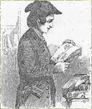
Nearly two hundred ___years___ ago, there lived in Boston a __little_ boy whose name was Benjamin Franklin. __When__ Benjamin Franklin was a __boy__ there were no great public __schools in Boston as there are now. But he learned to read almost as __soon__ as he could talk, and he was __always__ fond of books.
His nine brothers were __older__ than he, and every one had learned a trade. They did not care so much for __books__. "Benjamin shall be the scholar of our family," said his __mother__.
And so, when he __was__ eight __years__ old, Benjamin Franklin was sent to a grammar ___school__, where boys were prepared for college. He was a very apt scholar, and in a few __months__ was promoted to a higher class.
But the lad was not allowed to stay long in the grammar school. His father was a __poor___ man. It would cost a great deal of money to give Benjamin a college education. The times were very __hard_. The idea of educating the __boy__ had to be given up. In less than a year he was taken from the grammar school, and sent to __another__ school where arithmetic and writing were taught.
A00115
He __learned__ to write very well. But he did not care so much for arithmetic, and so failed to __do__ what was expected of him.
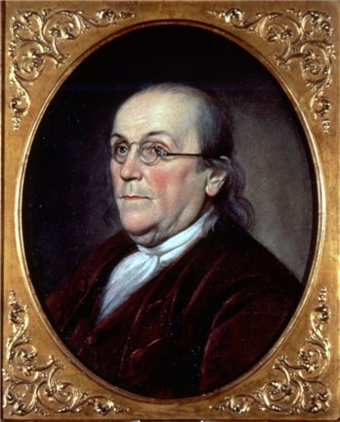
When he was __ten__ years old he had to leave school altogether. His father needed his __help__, and there were many things that he could do.
He never attended school again. But he kept on studying and __reading__; and we shall find that afterwards __became__ the most learned man in _____America.

Vocabulary
Lad: | Noun- boy or young man
Fond: | Adjective: to like someone or something very much
Scholar: | Noun- A person with much education.
Apt: | Adjective- 1) Exactly right for a situation or purpose. 2) Able to learn or understand quickly.
Learned: | Verb- Past of “to learn”;  Adjective- Educated

THE STORY OF BENJAMIN FRANKLIN
(His early years)
Nearly two hundred __________ ago, there lived in Boston a _______ boy whose name was Benjamin Franklin. _________ Benjamin Franklin was a _______ there were no great public _________ in Boston as there are now. But he _________ to read almost as ___________ as he could talk, and he was ____________ fond of books.
His nine brothers were __________ than he, and every one had learned a trade. They did not care so much for __________. "Benjamin shall be the scholar of our family," said his ____________.
And so, when he ________ eight _________ old, Benjamin Franklin was sent to a grammar ______________, where boys were prepared for college. He was a very apt scholar, and in a few ____________ was promoted to a higher class.
But the lad was not allowed to stay long in the grammar school. His father was a __________ man. It would cost a great deal of money to give Benjamin a college education. The times were very ________. The idea of educating the _______ had to be given up. In less than a year he was taken from the grammar school, and sent to ____________ school where arithmetic and writing were taught.
A00115
He __________ to write very well. But he did not care so much for arithmetic, and so failed to _________ what was expected of him.
When he was _________ years old he had to leave school altogether. His father needed his _________, and there were many things that he could do.
He never attended school again. But he kept on studying and ___________; and we shall find that afterwards ____________ the most learned man in ________________.

Vocabulary
Lad: | Noun- boy or young man
Fond: | Adjective: to like someone or something very much
Scholar: | Noun- A person with much education.
Apt: | Adjective- 1) Exactly right for a situation or purpose. 2) Able to learn or understand quickly.
Learned: | Verb- Past of “to learn”;  Adjective- Educated

