Abraham Lincoln – 16th President A00112
Section | Pages
Full document | 2 - 3
Student “Fill in” document | 4 - 5

This material was adapted by Peter Schmitt from an article about Lincoln on the Simple English Wikipedia website.
Audio is read by Rhonda Schmitt
(http://simple.wikipedia.org/wiki/Abraham_Lincoln)


Abraham Lincoln Name:_____________________
(Based on an article from Simple English Wikipedia)
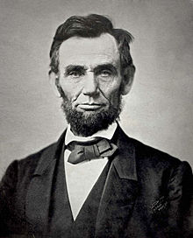
Abraham Lincoln lived from 1809 until 1865. He was the 16th President of the United States. He was President during the American Civil War. He is famous because he worked to end slavery in the United States.
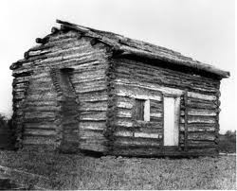
Abraham Lincoln was born on February 12th, 1809 in the state of Kentucky. His parents were named Thomas and Nancy. Lincoln’s family was poor. He grew up in a small, one room log cabin. Lincoln’s family moved to Indiana when Abraham was seven years old. Later they moved to Illinois. When Abraham Lincoln was young, he helped his father with work on the farm. He did not attend school for very long. Some say that he only went to school for one year.
Lincoln left home when he was 22 years old. After he left home, he worked in a “general store.” In 1842 he married Mary Todd Lincoln. They had four children. Three of the children died when they were still young.
People knew that they could trust Abraham Lincoln. Because of that, he is sometimes called “Honest Abe.”
In 1837 Lincoln began to work as a lawyer. He was one of the most respected lawyers in Illinois. He became a representative in the state legislature. There he spoke against slavery. In 1846 he became a member of the United States House of Representatives.
In 1860 Lincoln was elected President of the United States. Soon after his election, eleven states in the southern part of the United States declared independence from the U.S. They called themselves the “Confederacy.” Those states believed in slavery. They were afraid that if they remained in the United States, they would not be able to keep their slaves. The American Civil War was fought from 1861 until April 9th 1865.
A00112
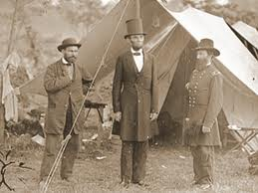
During the Civil War, Lincoln led the nation. On January 1st, 1863, he made a proclamation. It said that the slaves in the southern states were free. Lincoln did not live long enough to see the reunification of the nation. On April 14th 1865 Lincoln was shot in the head. He died the next day. He was the first President to be assassinated.
Many say that Abraham Lincoln was one of the greatest Presidents of the United States.

Check Your Understanding
- Where was Abraham Lincoln born? __________________________________
- Did Lincoln’s family have a lot of money? ____________________________
- Did Abraham Lincoln work in a bank? ________________________________
- Was Lincoln the 5th President? _______________________________________
- Did Lincoln support slavery? __________________________________________
- What was the “Confederacy?” ______________________________________
- How did Lincoln die? ________________________________________________

Abraham Lincoln Name:_____________________
(Based on an article from Simple English Wikipedia)
A00112
Abraham Lincoln ______ from 1809 until 1865. He was the 16th President of the _______ States. He ____ President during the American Civil War. He is famous because he ________ to end slavery in the United States.
Abraham Lincoln was born on _________ 12th, 1809 in the state of Kentucky. His ___________ were named Thomas and Nancy. Lincoln’s _______ was poor. He grew up in a _____, one room log cabin. Lincoln’s family moved to Indiana _____ Abraham was seven ______ old. Later they moved to Illinois. When Abraham Lincoln was ______, he helped his father with work on the ______. He did not attend ________ for very long. Some say that he only went to school for one year.
Lincoln left home when he ________ 22 years old. After he left home, he __________ in a “general store.” In 1842 he married Mary Todd Lincoln. They had four __________. Three of the children died when ________ were still young.
People knew _____ they could trust Abraham Lincoln. Because of that, he is ____________ called “Honest Abe.”
In 1837 Lincoln ______ to work as a lawyer. He was one of the most respected lawyers in Illinois. He became a representative in the ________ legislature. There he spoke against slavery. In 1846 he became a member of the United ______ House of Representatives.
In 1860 Lincoln ________ elected President of the United States. Soon ______ his election, eleven states in the southern ______ of the United States declared independence _______ the U.S. They called themselves the “Confederacy.” ________ states believed in slavery. They were ________ that if they remained in the United States, they would not be able to keep _______ slaves. The American Civil War was _________ from 1861 until April 9th 1865.
A00112
During the Civil War, Lincoln led the nation. On January 1st, 1863, he _______ a proclamation. It _____ that the slaves in the southern states _______ free. Lincoln did not live _____ enough to see the reunification of the nation. On April 14th 1865 Lincoln ______ shot in the _____. He died the next day. He was the first President to be assassinated.
Many _______ that Abraham Lincoln was one of the greatest Presidents of the United States.

Check Your Understanding
- Where was Abraham Lincoln born? __________________________________
- Did Lincoln’s family have a lot of money? ____________________________
- Did Abraham Lincoln work in a bank? ________________________________
- Was Lincoln the 5th President? _______________________________________
- Did Lincoln support slavery? __________________________________________
- What was the “Confederacy?” ______________________________________
- How did Lincoln die? ________________________________________________

